**ASSIGNMENT NO 12**

**(Group B: MongoDB Assignment No 3**

**Assignment Name: -**. MongoDB Map Reduce

**Title of Assignment:** Implement Map reduce operation with suitable example using MongoDB.

**Theory: -**

**Map-Reduce**

**• Map-reduce is a data processing paradigm for condensing**

large volumes of data into useful aggregated results. For mapreduce operations, MongoDB provides the mapReduce database command.

**• Consider the following map-reduce operation:**

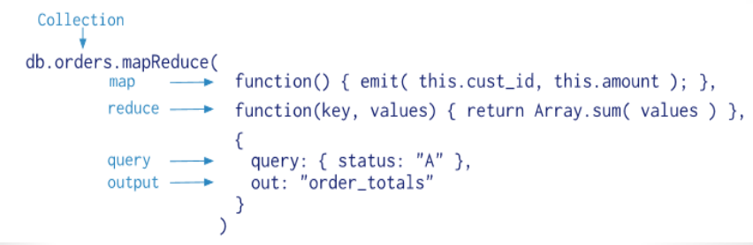

**MapReduce:**

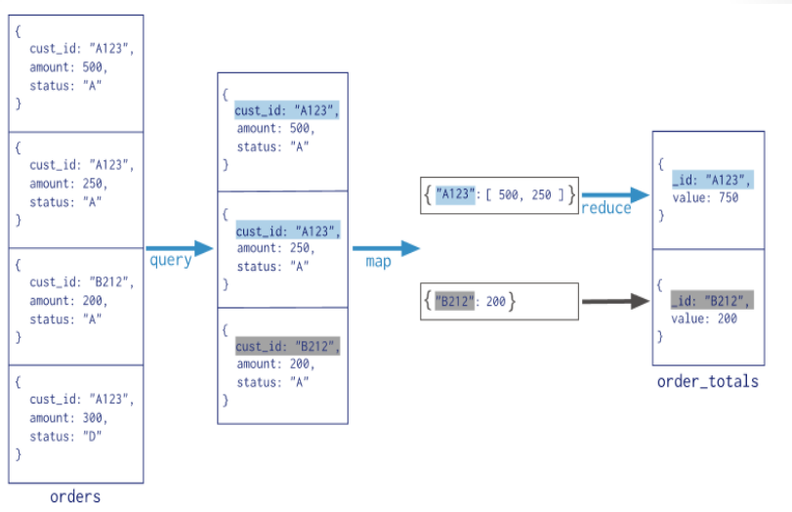

**Maf**very simple terms, the mapReduce command takes 2 primary inputs, the mapper function and the reducer function.

A Mapper will start off by reading a collection of data and building a Map with only the required fields we wish to process and group them into one array based on the key.

And then this key value pair is fed into a Reducer, which will process the values.

**Map-Reduce Syntax:**

db.collection.mapReduce(

function() {emit(key, value);},

function(key,values) {return reduceFunction},

{

out: collection,

query: document,

sort: document,

limit: number

}

)

**Map-Reduce Syntax Explanation:**

The above map-reduce function will query the collection, and then map

the output documents to the emit key-value pairs. After this, it is

reduced based on the keys that have multiple values. Here, we have

used the following functions and parameters.

• Map: – It is a JavaScript function. It is used to map a value with a key and

produces a key-value pair.

• Reduce: – It is a JavaScript function. It is used to reduce or group

together all the documents which have the same key.

• Out: – It is used to specify the location of the map-reduce query output.

• Query: – It is used to specify the optional selection criteria for selecting

documents.

• Sort: – It is used to specify the optional sort criteria.

• Limit: – It is used to specify the optional maximum number of

documents which are desired to be returned.

**Conclusion:**

In this assignment we have studied about Map reduce operation with suitable example using MongoDB.